11/01/17
THM 348 Service Operations Management
Final Exam
- JCA is a lecturer at “Bilkent University”, a prestigious well-known university in the world. In his effort to improve the quality of learning, JCA prepared SurvQual questionnaire and communicated it to all his students. Upon analysis of said questionnaire, JCA realized that students spelled out their dissatisfaction in the following areas along with the frequency of those very problematic areas:
- Prepare a Pareto Chart for the above data. (2 Points)
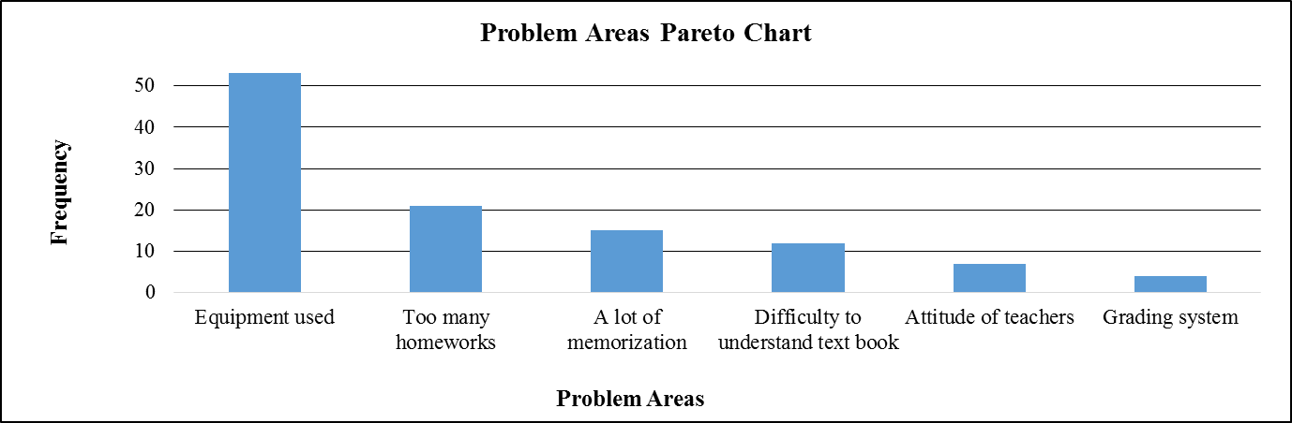
- As “Equipment used” problem had the highest frequency amongst the other problems, JCA decided to tackle this first. He convinced higher management to renew all audiovisual equipment in various laboratories and in-focus classrooms. After 14 weeks, he wanted to see if there are any quality improvements in the process. To see this, he decided to use run chart. He prepared the following table depicting weekly related students’ complaints (before / after renewing). The following table reveals the following results:
- Prepare a run chart to compare student complaints before and after renewing audiovisual equipment. (2 Points)

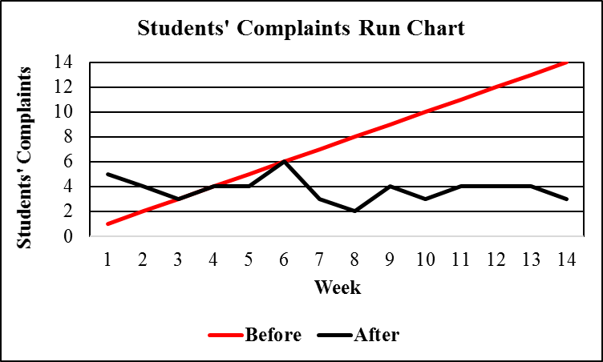

d) Analyze the finding in part b). Is there any improvement as far as students’ complaints are concerned after renewing audiovisual equipment? If there is an improvement, what is the next problem that JCA shall try and solve? (1 Point)
As seen from the run chart prepared in part b), there is a clear improvement as far as students’ complaints are concerned after renewing audiovisual equipment. The next problem that JCA shall try and solve is “Too many homeworks”.
- Contrast “Cognitive knowledge” and “Self-motivated creativity”. (2 Points)
While “cognitive knowledge” (know-what) is the basic mastery of a discipline achieved through extensive training and certification, “self-motivated creativity” (care-why) consists of will, motivation, and adaptability for success.
- What are the components of “non-billable activities”? By providing an example, explain how “non-billable activities”” affect utilization. (2 Points)
The components of “non-billable activities” are as follows:
- Business development
- Training
- General management
To illustrate, consulting firms have functional groups consisting of 6 – 10 billable staff members. If a dedicated manager is assigned to a group of 9 billable personnel, the utilization of the group immediately falls to 90 % at best. Without the manager, the group might be more profitable (in the short term), but the group would quickly become disorganized and less competitive (in the long run).
- What is the major risk of service diversification? How can service operation firms overcome this very problem? (2 Points)
The major risk of service diversification is potential loss of focus and neglect of the core service. To overcome this very problem, service operation firms use a strategy called “Concentric diversification”
- How can service operation companies achieve “Global localization”? Provide 2 examples of companies attaining this very strategy. (3 Points)
Service operation companies can achieve “global localization” by becoming close to their customers in the foreign country and accommodate their unique service needs. To illustrate, fast food chains would sell wraps with Ayran in Turkey instead of a hamburger and a coke in the US. Another example is Mr. Donut Japan, which changed everything about its product and service except the logo.
- During the past season, Kartel Resort Hotel did not achieve very high occupancy rates despite a reservation system that was designed to keep the hotel fully booked. Apparently, prospective guests were making reservations that, for one reason or another, they failed to honor. A review of Front-desk records during the current peak period, when the Resort Hotel was fully booked, revealed the record of no-shows as shown in the below table:
No-shows | Probability | Reservations Overbooked | Cumulative Probability
0 | 0.06 | 0 | 0.00
1 | 0.08 | 1 | 0.06
2 | 0.03 | 2 | 0.14
3 | 0.10 | 3 | 0.17
4 | 0.14 | 4 | 0.27
5 | 0.18 | 5 | 0.41
6 | 0.13 | 6 | 0.59
7 | 0.08 | 7 | 0.72
8 | 0.10 | 8 | 0.80
9 | 0.06 | 9 | 0.90
10 | 0.04 | 10 | 0.96
Suppose that a vacant room (because of No Show) results in an opportunity loss of $ 75.
- Calculate the Expected Number of No Show Rooms. (2 Points)
- Expected number of no show rooms = (0.06 * 0) + (0.08 * 1) + (0.03 * 2) + (0.10 * 3) + (0.14 * 4) + (0.18 * 5) + (0.13 * 6) + (0.08 * 7) + (0.10 * 8) + (0.06 * 9) + (0.04 * 10) = 0 + 0.08 + 0.06 + 0.30 + 0.56 + 0.90 + 0.78 + 0.56 + 0.80 + 0.54 + 0.40 = 4.98 rooms.
- Calculate the Expected Opportunity Loss. (1 Point)
- Expected Opportunity Loss = 4.98 * 75 = $ 373.50.
In order to avoid some of this loss, Kartel Resort Hotel management is considering an overbooking policy. Yet, if a guest holding a reservation is turned away (due to overbooking), other costs would be incurred. Kartel Resort Hotel has made arrangements with a nearby Resort Hotel (Kartal Resort Hotel) to pay for the rooms of guests whom it cannot accommodate. Further, a penalty is associated with the loss of customer goodwill and the impact this has on future business. Management estimates this total loss to be approximately $ 160 per turned out guest.
- Fill the below Overbooking Loss Table (4 Points)
 |  | Reservations Overbooked
No-shows | Prob. | 0 | 1 | 2 | 3 | 4 | 5 | 6 | 7 | 8 | 9 | 10
0 | 0.06 | $0 | $160 | $320 | $480 | $640 | $800 | $960 | $1,120 | $1,280 | $1,440 | $1,600
1 | 0.08 | $75 | $0 | $160 | $320 | $480 | $640 | $800 | $960 | $1,120 | $1,280 | $1,440
2 | 0.03 | $150 | $75 | $0 | $160 | $320 | $480 | $640 | $800 | $960 | $1,120 | $1,280
3 | 0.10 | $225 | $150 | $75 | $0 | $160 | $320 | $480 | $640 | $800 | $960 | $1,120
4 | 0.14 | $300 | $225 | $150 | $75 | $0 | $160 | $320 | $480 | $640 | $800 | $960
5 | 0.18 | $375 | $300 | $225 | $150 | $75 | $0 | $160 | $320 | $480 | $640 | $800
6 | 0.13 | $450 | $375 | $300 | $225 | $150 | $75 | $0 | $160 | $320 | $480 | $640
7 | 0.08 | $525 | $450 | $375 | $300 | $225 | $150 | $75 | $0 | $160 | $320 | $480
8 | 0.10 | $600 | $525 | $450 | $375 | $300 | $225 | $150 | $75 | $0 | $160 | $320
9 | 0.06 | $675 | $600 | $525 | $450 | $375 | $300 | $225 | $150 | $75 | $0 | $160
10 | 0.04 | $750 | $675 | $600 | $525 | $450 | $375 | $300 | $225 | $150 | $75 | $0
Expected | ------- | 373.50 | 312.60 | 270.50 | 235.45 | 223.90 | 245.25 | 308.90 | 403.10 | 516.10 | 652.60 | 803.20
Loss ($)
- How many rooms shall be overbooked? Why? (2 Points)
According to the above overbooking loss table, 4 rooms shall be overbooked, since, this very scenario yields the least expected loss.
N.B: Your answers to parts a), b) c) & d) shall be rounded to the nearest cent.
- Contrast “Request variability” to “Subjective preference variability”. Provide 1 example for each of those very variabilities. (2 Points)
While “request variability” results from unique demands of customers that create uneven service times, “subjective preference variability” results from the expectation of what it means to be treated well. An example of request variability would be a bank customer who wants to purchase a CD (Certificate of Deposit) and another customer who wants to cash a check. On the other hand, an example of subjective preference variability would be one diner might appreciate the warmth of a waiter’s first name introduction while another resents the presumption of intimacy.
Good Luck

